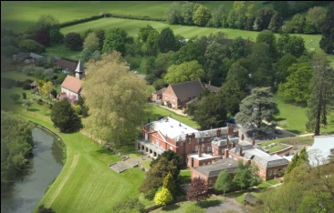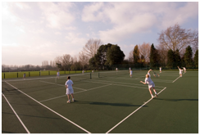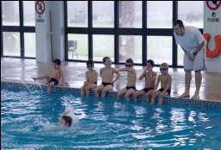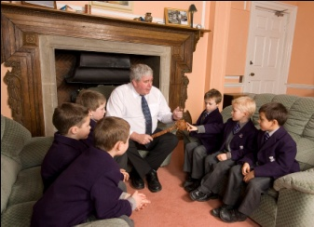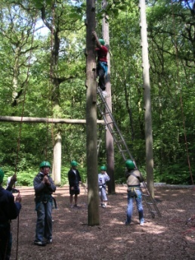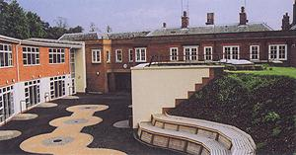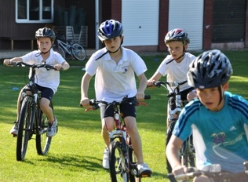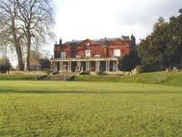

**Headmaster**

**6 Set the text box to transparent and change the writing to so you can read it.**

**9 Text Wrap (in front of text) and straighten this logo**

**8 Put this picture into the shape of the Sun**

**7 Make the pictures the same size and bring the swimming one to the front.**

**5 Put a white boarder around this picture**

**4 Change the brightness on this picture to make it look clearer.**

**3 Flip this picture to make it the right way up!**

**2 Crop this picture so you are just left with the manor building**

**1 Remove the white background from the pussdog**

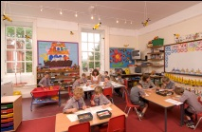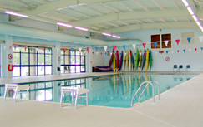**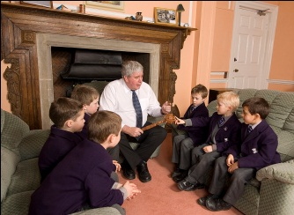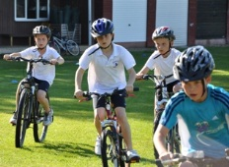[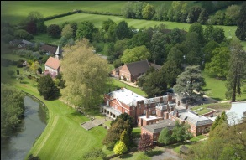](http://www.parkside-school.co.uk/)**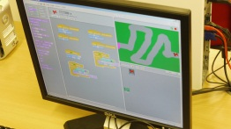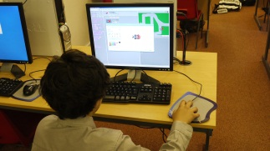

**14 Add the word TRIATHLON to the image right in the middle in white**

**13 Hyperlink this picture to parkside-school.co.uk**

**18 Reshape this picture so it is in the right aspect**

**15 Put this picture into a circular frame**

**12 Add a picture of Parkside into this shape**

**11 Remove this picture border**

**17 delete all the pictures here apart form one**

**16 Bring this picture to the front!**

**10 Un-crop this picture back to its original state.**